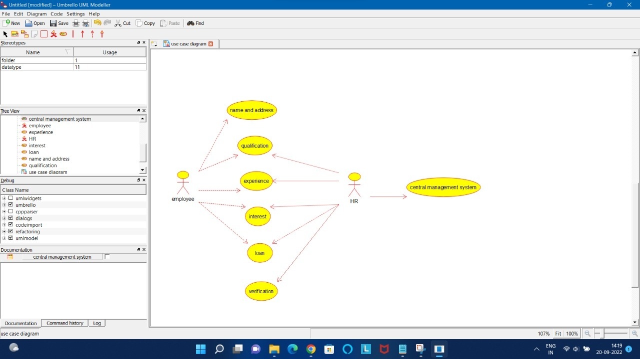

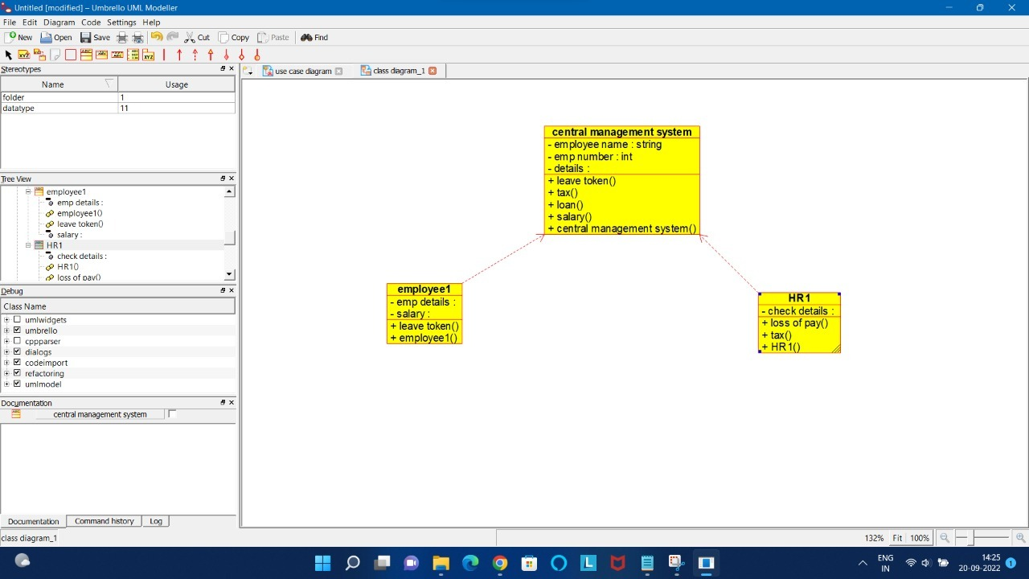

/**

* Class central_management_system

*/

public class central_management_system {

//

// Fields

//

private String employee_name;

private int emp_number;

private void details;

//

// Constructors

//

public central_management_system () { };

//

// Methods

//

//

// Accessor methods

//

/**

* Set the value of employee_name

* @param newVar the new value of employee_name

*/

private void setEmployee_name (String newVar) {

employee_name = newVar;

}

/**

* Get the value of employee_name

* @return the value of employee_name

*/

private String getEmployee_name () {

return employee_name;

}

/**

* Set the value of emp_number

* @param newVar the new value of emp_number

*/

private void setEmp_number (int newVar) {

emp_number = newVar;

}

/**

* Get the value of emp_number

* @return the value of emp_number

*/

private int getEmp_number () {

return emp_number;

}

/**

* Set the value of details

* @param newVar the new value of details

*/

private void setDetails (void newVar) {

details = newVar;

}

/**

* Get the value of details

* @return the value of details

*/

private void getDetails () {

return details;

}

//

// Other methods

//

/**

*/

public void leave_token()

{

}

/**

*/

public void tax()

{

}

/**

*/

public void loan()

{

}

/**

*/

public void salary()

{

}

/**

*/

public void central_management_system()

{

}

}

[2:27 pm, 20/09/2022] Pooja Classmate: /**

* Class central_management_system

*/

public class central_management_system {

//

// Fields

//

private String employee_name;

private int emp_number;

private void details;

//

// Constructors

//

public central_management_system () { };

//

// Methods

//

//

// Accessor methods

//

/**

* Set the value of employee_name

* @param newVar the new value of employee_name

*/

private void setEmployee_name (String newVar) {

employee_name = newVar;

}

/**

* Get the value of employee_name

* @return the value of employee_name

*/

private String getEmployee_name () {

return employee_name;

}

/**

* Set the value of emp_number

* @param newVar the new value of emp_number

*/

private void setEmp_number (int newVar) {

emp_number = newVar;

}

/**

* Get the value of emp_number

* @return the value of emp_number

*/

private int getEmp_number () {

return emp_number;

}

/**

* Set the value of details

* @param newVar the new value of details

*/

private void setDetails (void newVar) {

details = newVar;

}

/**

* Get the value of details

* @return the value of details

*/

private void getDetails () {

return details;

}

//

// Other methods

//

/**

*/

public void leave_token()

{

}

/**

*/

public void tax()

{

}

/**

*/

public void loan()

{

}

/**

*/

public void salary()

{

}

/**

*/

public void central_management_system()

{

}

}

[2:27 pm, 20/09/2022] Pooja Classmate: /**

* Class employee1

*/

public class employee1 {

//

// Fields

//

private void emp_details;

private void salary;

//

// Constructors

//

public employee1 () { };

//

// Methods

//

//

// Accessor methods

//

/**

* Set the value of emp_details

* @param newVar the new value of emp_details

*/

private void setEmp_details (void newVar) {

emp_details = newVar;

}

/**

* Get the value of emp_details

* @return the value of emp_details

*/

private void getEmp_details () {

return emp_details;

}

/**

* Set the value of salary

* @param newVar the new value of salary

*/

private void setSalary (void newVar) {

salary = newVar;

}

/**

* Get the value of salary

* @return the value of salary

*/

private void getSalary () {

return salary;

}

//

// Other methods

//

/**

*/

public void leave_token()

{

}

/**

*/

public void employee1()

{

}

/**

* Class HR1

*/

public class HR1 {

//

// Fields

//

private void check_details;

//

// Constructors

//

public HR1 () { };

//

// Methods

//

//

// Accessor methods

//

/**

* Set the value of check_details

* @param newVar the new value of check_details

*/

private void setCheck_details (void newVar) {

check_details = newVar;

}

/**

* Get the value of check_details

* @return the value of check_details

*/

private void getCheck_details () {

return check_details;

}

//

// Other methods

//

/**

*/

public void loss_of_pay()

{

}

/**

*/

public void tax()

{

}

/**

*/

public void HR1()

{

}

}